|  |  |
| --- | --- |
|  | COM3504/COM6504 Intelligent Web Assignment 2020-2021 |

This assignment is primarily concerned with applying the ideas that are being presented in the module on methods for accessing the Web and making sense of its content. In providing a solution, you are required to use the methods and techniques taught in the module.

## Scenario

You are supporting some secret agents who need to exchange relevant information with another agent using images and text. The information is in the form of images and annotations. Annotations can be textual or hand drawn using the mouse, e.g showing a path to follow to get a package, instructions on how to open doors, etc. Instructions can be composed of multiple images. For example

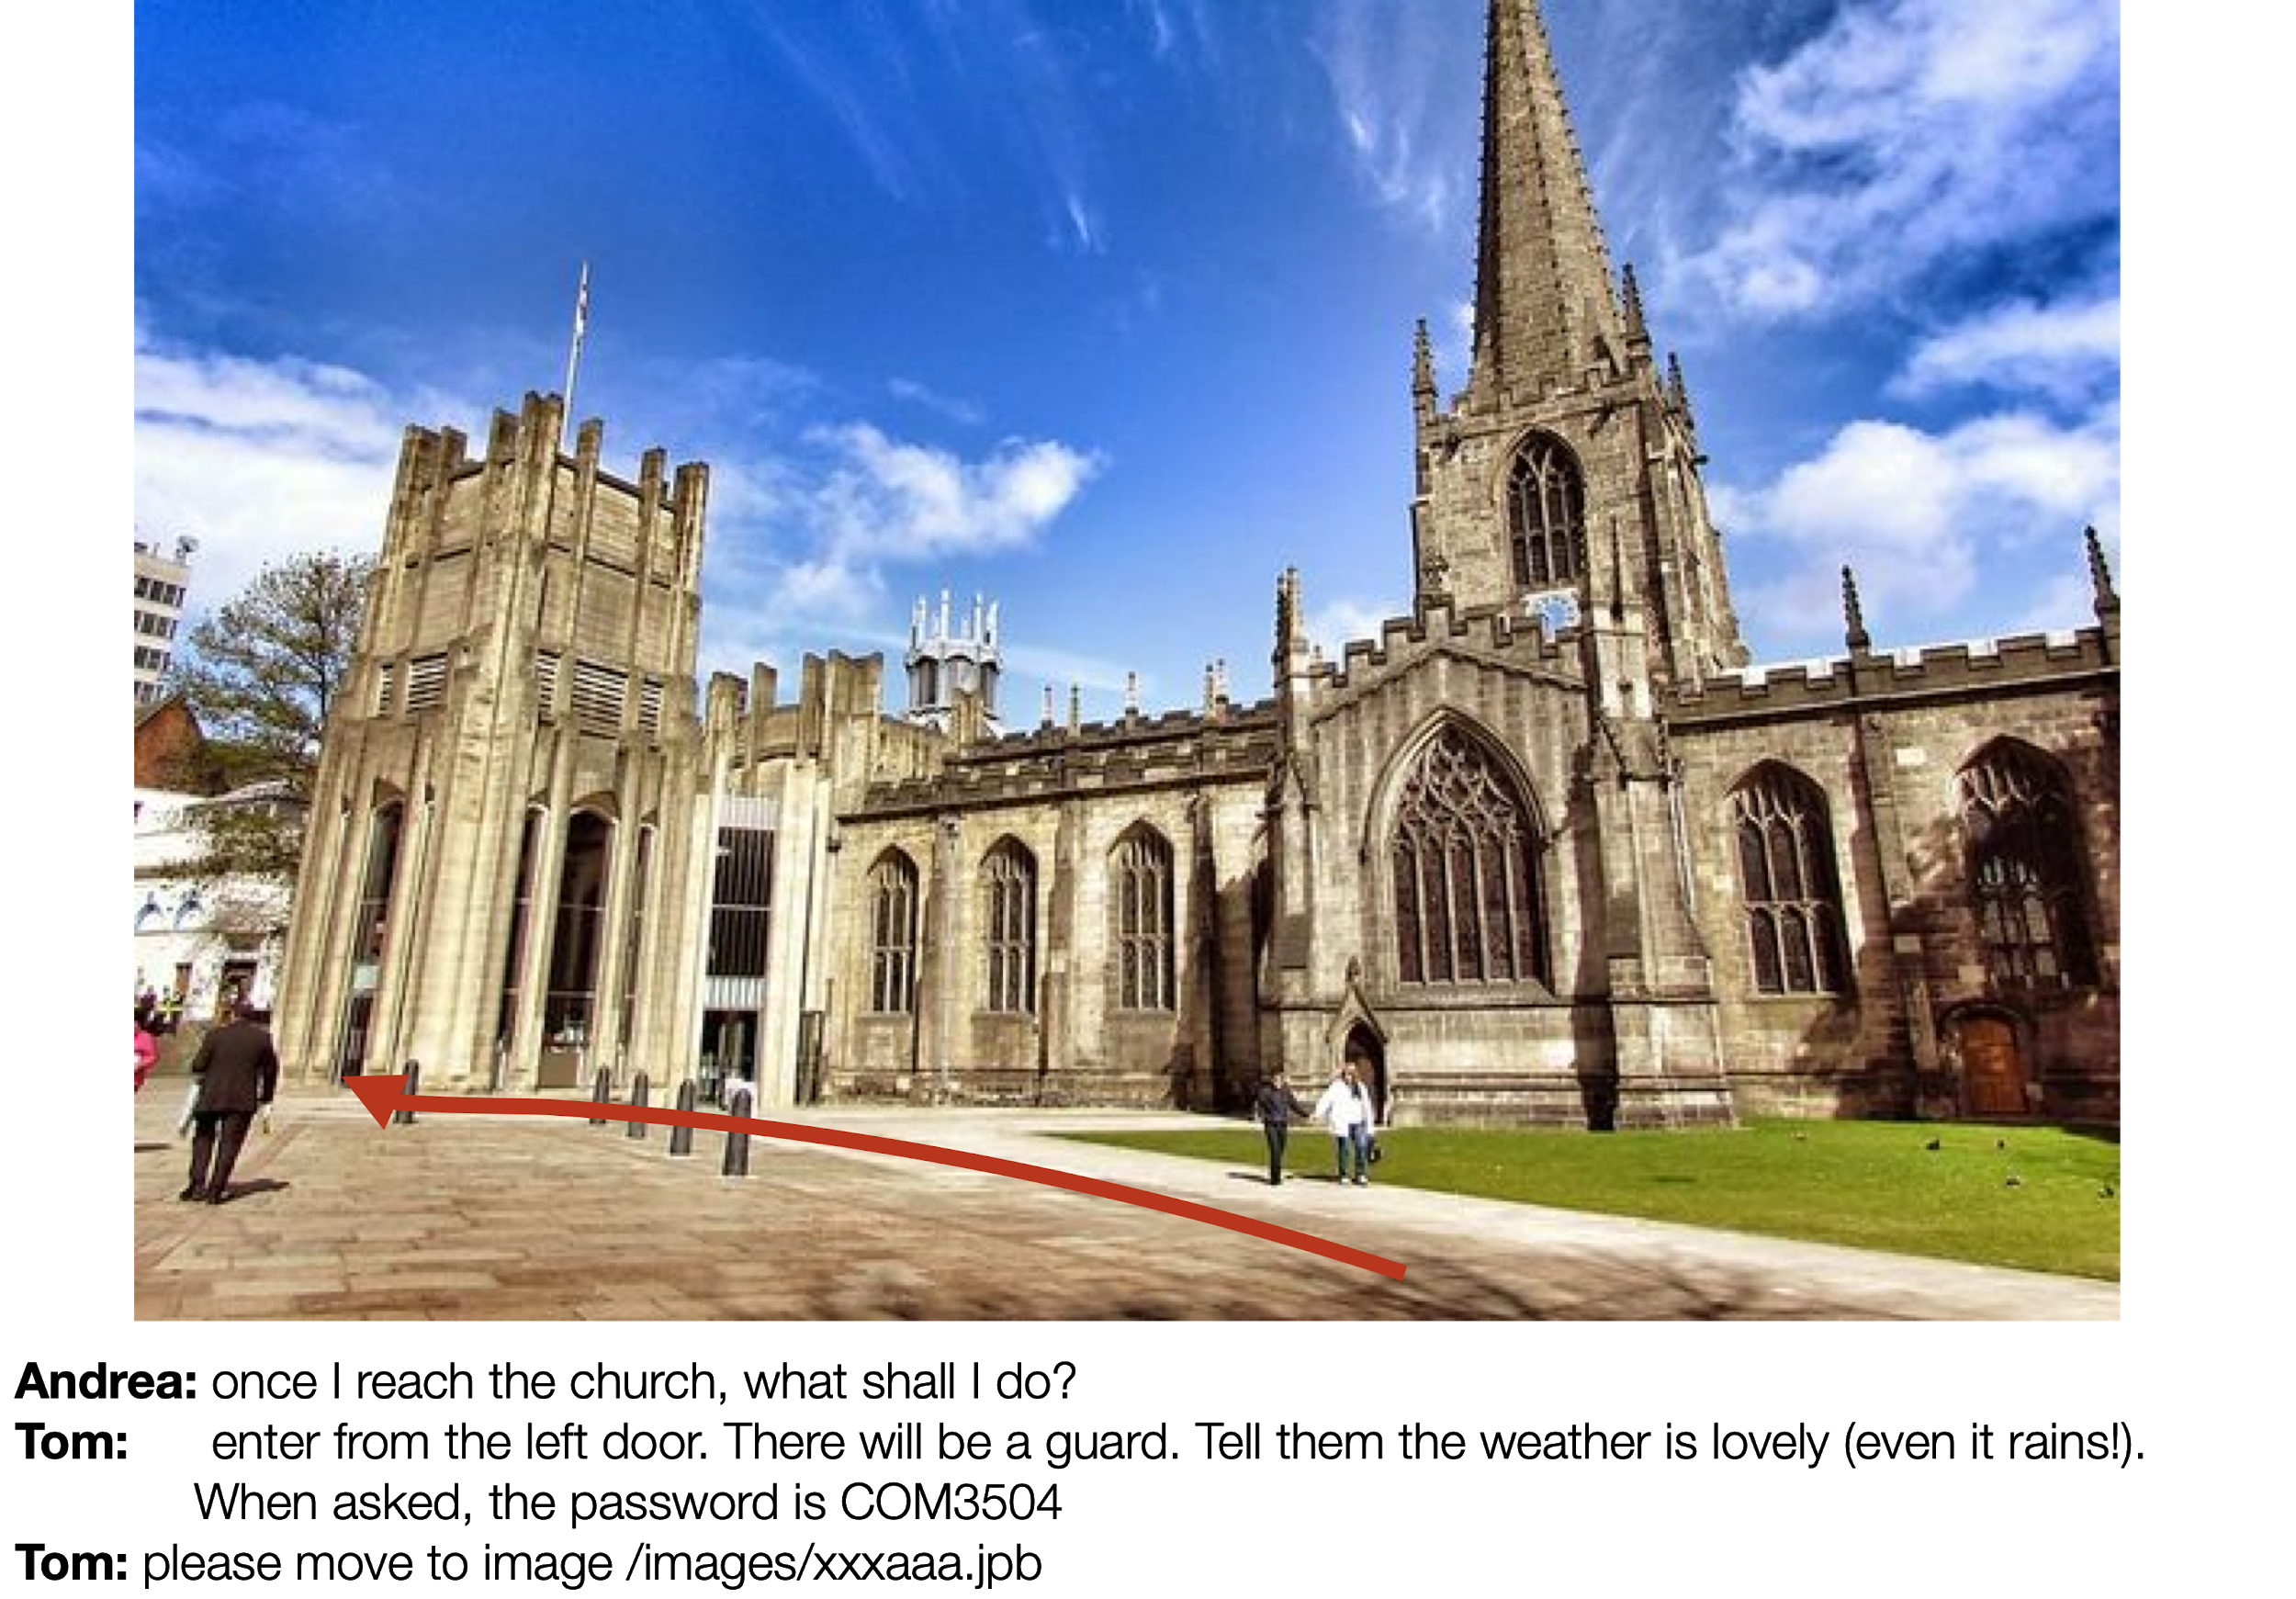

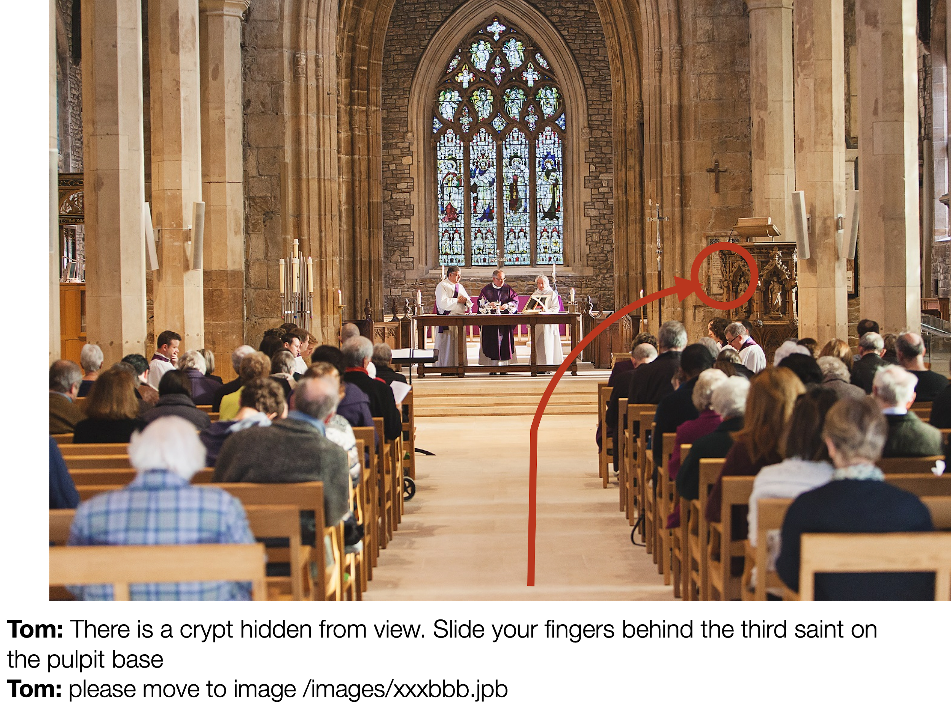



To do:

* Implement a site where people can upload, share (with a direct URL) and annotate images;
* The system implements a chat system so that users can discuss an image’s content.
* Images can be annotated using the mouse (e.g. by drawing lines) during a chat session. Both the chat text and the hand drawn elements are considered annotations, as the text may complement each other.
* The annotation and chat are interactive, so they are seen by all participants while they are made. Different users can draw on the image at the same time. See explanation video.

There are different parts in the application and they are discussed below.

## The Web app

* It allows taking and uploading pictures;
* Images are associated with a title and a description, as well as the author's name. The name is just a string - no need to implement a login system.
* Images can be listed by their author’s name and one can be picked for annotation by clicking on it.
* Users can see all the images of all the other users (so no need to implement a login and privacy system)

How would you do that? Take a picture or upload a picture to the page using either an HTML5 form or (better) WebRTC. Then send the image to the database using Ajax. The use of Ajax is required. Data (e.g. title, description and author) must be exchanged using JSON. Images can be uploaded in base 64 (suggested) or using libraries like multi (not suggested). Images are uploaded to a MongoDB database.

Images that are just linked do not need to be uploaded to the database (e.g. as implemented in the code provided as a starting point).

### The chat and annotation interface

* The user selects an image and enters a chat room
* An example of the expected interface is displayed in the image below.
  + The image to annotate is displayed
  + The chatroom is available
  + It allows annotating the image using the mouse.

You are provided with a starting point project that implements the drawing capability and provides a basic version of the chat interface. This will help you focus away from basic HTML/CSS issues.

Use socket.io to send both the chat text and the graphical annotations to the participants in the room. The starting point project provides some hints (@todo) on where to send the data. This should help you understand how the provided code works.

The annotation must be sent and received in real time (see video). The interface must allow moving to a different image while keeping the connection (so to create multi image stories - see example at the beginning of this document). You could simply implement a form saying connect to the next image that inputs a URL sent via chat to the other users.

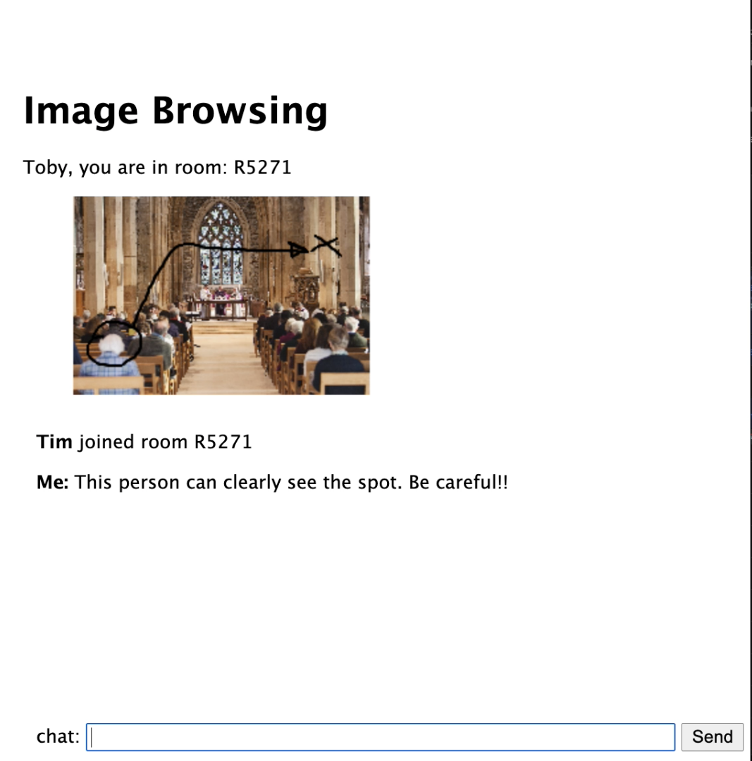

## Local Persistence

The participants in the chat persist the annotations and the chat text in a local IndexedDB database. They must cache:

* The actual image (e.g. in base64 format so that it can be stored into the IndexedDB) and its URL or id in the database.
* The annotations and the chat content
* Any transition to another image URL (this is so that when the instructions cover multiple images - see previous example- , it is possible to access the complete set of instructions).

When the user comes back to an image they have annotated, all the information above must be shown from the cache.

## Working offline

**The web app must display annotation and allow annotations both online and offline**.

When uploading a new picture, if the device is offline, the image must be stored into the IndexedDB in base64 format together with all the metadata (title, text, date, etc.). When the device goes online again, the image must be uploaded to the server’s database via Ajax.

Annotations from previous chats are saved in the indexedDB and displayed when the specific image URL is requested even when offline. It is possible to annotate while offline but the annotations are not shared with anybody. Cached images should never be updated even if they change in the database or online. This is because if the image changes, the annotations may make no longer sense.

## The server

The server must be implemented using NodeJS+Express and must support the chat system and the connection to MongoDb. The documentation must be provided via Swagger.

## Working with the knowledge graph

**\*\* this part was clarified on 29.04.2021 \*\*\***

Allow the user to annotate the images with information retrieved from Google’s knowledge graph. An example on how to annotate and present the information would be:

Annotation:

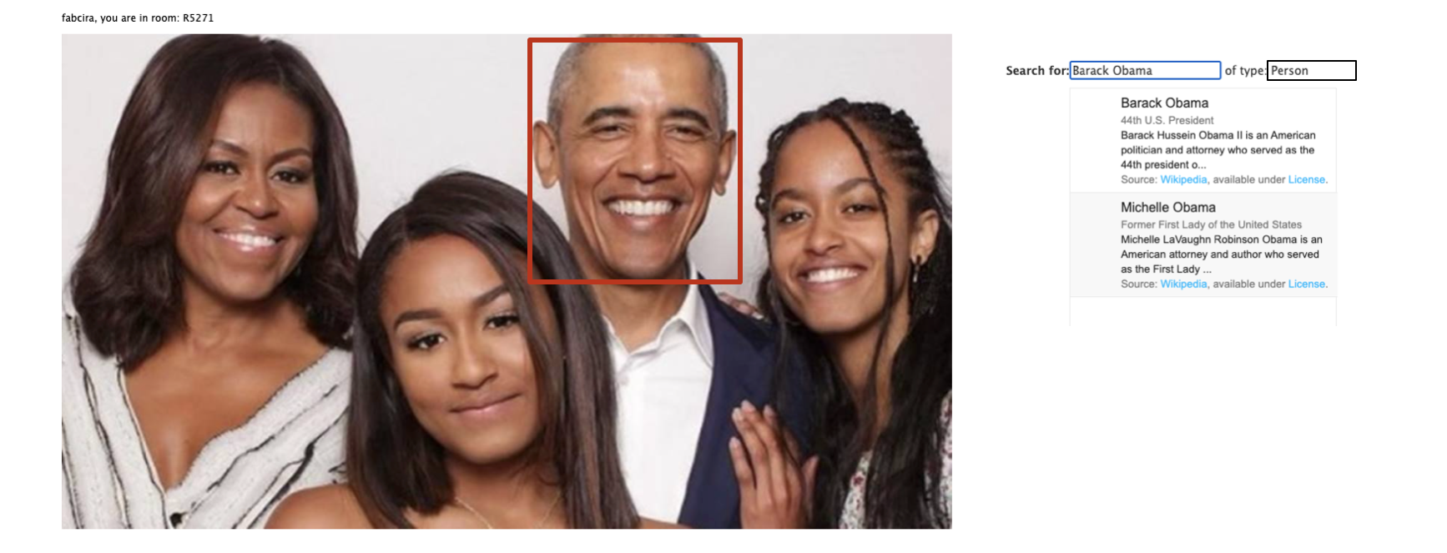

Presentation:

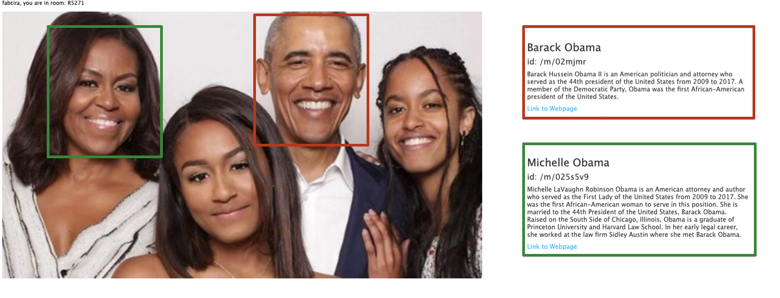

(you are free to choose how to actually present the information)

As for all the other annotations, this information is to be cached and displayed when the user accesses the image again. As it is not easy to read JSON, the information should be displayed using a human readable structure, e.g. via a table. The annotation must again be stored into the IndexedDB so to be available both online and offline. The information should be stored in the original JSON-LD format. It is fine to never update the cached version of the information retrieved from the knowledge graph.

## Groups, division of work and associated documentation

The 3 team members should share the development equally. I expect the following parts to be developed by the following team members:

Member 1: socket.io, service worker, the chat/annotation interface

Member 2: nodeJS server (excluding socket.io), MongoDB

Member 3: IndexedDb, Ajax communication, Swagger documentation

**Alternatively** the following division of work can be adopted as it distributes the workload in a fairer way for part 1:

Member 1: socket.io, nodeJS server, the chat/annotation interface

Member 2: service worker, MongoDB

Member 3: IndexedDb, Ajax communication, Swagger documentation

If your group is composed of only **two members**, the implementation of the MongoDb and the use of Ajax are not required. Ask the lecturer to check if this condition applies to you. Do not just assume it does!

Member 1: socket.io, service worker, the chat/annotation interface

Member 2: nodeJS server (excluding socket.io), IndexedDb, Swagger documentation

If your group is composed of **only one member**, you are required to do the following:

socket.io, service worker, the chat/annotation interface, nodeJS server, IndexedDb

Note that the above are just some of the functions required to develop a solution. The remaining functions must be shared fairly by the group.

The working of the group must be documented using a private **Github repository**. I expect the daily

commit by each member to be clearly visible, so that it is clear who has developed what and when. Please note the term **daily** commits. I expect to see the programme build progressively over time in the repo. Any large blocks of code suddenly appearing on the repository will be investigated for use of unfair means.

The whole assignment is intended to account for between 20 and 30 hours of each person’s work towards the module as a whole.

You must register your group on [Google Drive](https://drive.google.com/open?id=1hZ2VRFcGg55Z7icDs8Xqml5c48Bm9UIgNsV7R7D1Emg&authuser=0). The same link provides help in finding a suitable group until week 2.

Please note: you can only have groups within the same module code, i.e. all members must be either all in COM3504 or in COM6504. PhD students should ask the lecturer before joining a group.

Given a group, you will be expected to keep with that group for the whole of the assignment. However, if any problem arises that makes this difficult, you should notify the lecturer immediately, so that appropriate action can be taken. See lecture 1 slides on this topic.

This division must be explicitly stated in the self-assessment form where the expected distribution is described.

**All members of each group are required to submit on Blackboard.**

## Devising an appropriate solution

It is important for your solution to follow the patterns and material taught during the lectures. Solutions that adopt different approaches will attract low marks and in some cases zero marks. The goal of the assignment is to prove that you have learned from the module, rather than to prove you are able to write code that works.

## Deadlines; formative and summative assessment

The deadlines are fixed. You should therefore plan your work to aim at handing the report in at least a few days before the deadline – do not leave it until the deadline, just in case any minor thing goes wrong and you then find that you are late.

Note that the Computer Science department applies fairly severe penalties for handing coursework in late. If you want to look at the details you can find them on the University’s website.

Please refer to the slides of the week 1 lecture for risks and considerations on working in groups.

There are two deadlines:

* **Friday of Week 7 at 23:59:59 for part 1   
  ** please note** this is an indicative deadline - we need your solution before the 1:1 meeting in week 8 - be ready to demonstrate the solution from your computer
* **Friday of Week 12 at 23:59:59 for the entire assignment**

Formative feedback will be provided in 1:1 meetings in week 8. Submitting part 1 is not required but it is strongly recommended.

Part1 must cover everything listed above with the exception of

* MongoDB (just implement the annotation of linked images from the web for part 1 as already possible in the project provided as starting point) and
* Swagger documentation and
* the connection with the knowledge graph.

The final submission will include the entire system; you will have to resubmit also a revised version of part 1.

## Material Provided and external libraries

**NOTE: no third party code can be used in the assignment,** except what has been **explicitly** provided in the lectures or lab classes. For example you are allowed to use code given in the lecture slides but you are not allowed to download any code from the Web or to use any other software that will perform a considerable part of the assignment. **Unauthorised re-use of third party software will be considered plagiarism.** In case of doubt ask the lecturer for permission before using any third party code. Libraries allowed, despite not being mentioned in the lecture notes are css/js libraries to improve the look and feel of any interface (e.g. Bootstrap). For other libraries, please ask before using.

List of allowed libraries:

· CSS/Javascript: Bootstrap

· NPM Libraries: Passport, Multer, Express, node static, body parser, etc.

· Code and libraries used in the labs and lectures

Examples of NOT allowed libraries:

· Angular: reason: it implements Ajax and the communication with the server in a proprietary way. This is considerable part of the assignment work.

· Any language that builds on top of Javascript and e.g. requires compilation

## Quality of the solution/ keeping your solution manageable

The assignment per se is rather simple, as it follows the module’s lab class exercises. However, we require a quality solution. While a simple solution will attract some good marks, a first class solution will have to provide sophisticated features. Some have been mentioned above.

Please note that the quality is not necessarily related to a stylish design (although that helps) or a high number of functionalities (ditto).

The quality must be intended as related to the module’s learning objectives mentioned above.

Having said that, please note that the assignment is open ended in some respects. Implementing a perfect solution would be far beyond the scope of this module. Make sure to keep the solution manageable in the time allocated to the module. Do not overdo it.

**The point of the assignment is to demonstrate that you master the techniques introduced by the module.** Designing a beautiful website with lots of functionalities for an amazing user experience may be tempting but is pointless.

The number of marks that will attract in terms of quality will not be worth the amount of time that will cost you.

I suggest instead that you spend your time working on the quality of the core solution and its documentation.

## Marking schema

Quality of the solution attracts 33% of the marks. Quality of the documentation attracts 33% of the marks, correctness of results attracts 33% of the marks. That means that having just a low quality solution providing correct results may be insufficient to get a pass mark.

**Marks for the different sections:**

1. Web app: 35%

o working both offline and online

o implementing a web worker

o implementing an indexedDB

2. NodeJS server: 20%

o Correct organisation of server and routes

o Correct Swagger documentation

o non-blocking organisation (use of promises and callbacks, multiple servers, etc.)

3. MongoDB: 15%

o Correct use of the MongoDB including correct organisation into models, controllers, etc.

4. Client/server communication 15%

o Correct use of Ajax and socket.io

5. Connection to the knowledge graph 15%

The quality of the code of your submission for each part of the assignment will account for quite a large part of the marks. We will check:

· Code functionality: how the code meets the requirements set in the assignment description.

· Code documentation. This includes

* + in-line commenting to make your code intentions clearer to someone reading
  + Javadoc-like and Swagger documentation: higher level comments on the code and its use. For more information on guidelines for code level documentation see http://www.oracle.com/technetwork/java/javase/documentation/index-137868.html
  + The full history of the development via Github

· Code runnability: we must be able to run your code without any problems using normal computers.

· Code quality**:** your code should follow a consistent format regarding class and variable naming as well as indentation, this can be easily achieved with the use of an IDE (IntelliJ). It must contain proper use and handling of Exceptions.

· Code organisation (e.g. readability, use of modules in node.js, Javascript files, etc.).

## Submitting

Your solution must be contained in a self-contained directory named after your group (this must be the same name you have registered with on the Google form (<MainDirectory> in the following) compressed into a zip file submitted through MOLE.

All the code should be in the directory <MainDirectory>/solution. Please note that we will both inspect and run the code.

(a) All code must be developed in HTML5/EJS /Javascript/CSS. We must be able to run your solution without problems on a standard machine. It should not need special installation of any external library other than running npm install.

(b)The external node modules must NOT be included in your submission. Just make sure to create a complete package.json file so that we can install all the modules running npm install. Some css and js libraries can be provided with external links in HTML/EJS files (e.g. you do not need to include JQuery, just link it in your HTML/EJS files).

Please note that the quality of the code carries a relevant portion of marks, so be sure to write it properly.

Moreover you are expected to submit:

1. A readme file clarifying any installation/running instruction. The task should be easy and self-explanatory but some instructions may help <MainDirectory>/README.
2. The documentation in the Javascript/HTML. The Swagger documentation.
3. A few screenshots or a video showing the app so that we can understand what should happen when we run your solution <MainDirectory>/screenshots
4. The filled **self-assessment form** stating what functionalities you have implemented and what is your confidence of having done an excellent piece of work. It is important that you make clear what contribution each group member has made to the solution.

Finally you are required to share your Github repo with **fabcira**, **jackdeadman** and **pegasus0642.**

## How to submit

Everything must be submitted electronically via MOLE. Store your solution in a .ZIP file that when unzipped will generate the directory organisation as described above. As an emergency measure (and only in that case!), if any last minute issue should arise in handing in electronically, please send your solution by email to the lecturer (cc to demonstrators) in a self contained .ZIP file.

If the division of roles in the group is balanced, all the members will get the same marks.

## Anti-cheat measures

Please note that measures are in place for detecting plagiarism and in general cheating.

## Queries about this assignment?

Should you have any queries about the assignment, feel free to contact

Fabio Ciravegna, Yunus Cogurcu, Jack Deadman

{f.ciravegna, yecogurcu1, jdeadman1}@ shef.ac.uk